Basic Knowledge to be an AbbA Israelite

Welcome, Everybody, and You too.
Thank God for your presence.

This is basic knowledge about God, AbbA Father and you, an AbbA Israelite. Read before and after each verse in the King James bible for more understanding of the message, so you know this is God’s message not mine. Check off the list as you review each subject. You can also go to israelitesadoption.org/The Adoption of AbbA Israelites for more knowledge and join.

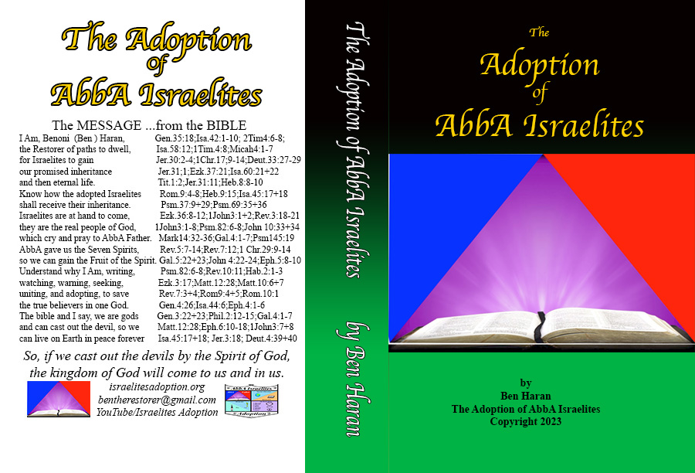

Matthew 18:18+19 Verily I say to you, Whatsoever you shall bind on earth shall be bound in heaven: and whatsoever you shall loose on earth shall be loosed in heaven.19 Again I say to you, That if two of you shall agree on earth as touching any thing that they shall ask, it shall be done for them of my Father which is in heaven.

Our Flag and Tabernacle Colors – Blue, Purple, Red

Exodus 26:1 You shall make the tabernacle with ten curtains of fine twined linen, and blue, and purple, and scarlet: with cherubims of cunning work you shall make them.

AbbA

AbbA is spelled with two capital A’s because God is first and last. Put nothing between you and God, AbbA Father. AbbA means Father. So, have no division between you brothers and sisters of faith and Earth.

Isaiah 44:6 The LORD the King of Israel, and his redeemer the LORD of hosts says; I am the first, and I am the last; and beside me there is no God.

How do we pray?

We cry to AbbA Father - Exodus 22:23; Psalm 106:44-48; Romans 8:8-17;
Revelation 7:9+10; Psalm 34:7; Galatians 4:1-6

Dressed in White -

____ God - White Raiment - Revelation 15:5+6; Revelation 4:4

____ You – White Raiment - Revelation 7:13-17; Revelation 3:2-6;
Revelation 7:9-15

____ God – AbbA, Father - Romans 8:8-17; Galatians 4:1-6; Mark 14:32-36;
John 14:10-21; Ephesians 4:1-6

____ You - Adoption – Romans 8:23-28; Romans 9:2-6; Ephesians 1:4-23
Isaiah 44:1-6; Isaiah 43:1; Isaiah 65:14-17;
Isaiah 43:5-7; Exodus 3:13-15

____ God - Sons of God – 1 John3:1-8; Romans 8:8-23; John 10:25-38
Psalm 82:6-8; 1 John4:4-21; Matthew 12:50
Matthew 19:29; Ephesians 6:10-18

____ You – Israelites – Chosen People – 2 Samuel 7:22-24; Revelation 21:5-7
Ezekiel 18:27-30; Ezekiel 36:8-12; Ezekiel 37:11-17
Psalm 105:6-11; Jeremiah 31:31-34; Isaiah 41:8-14
1 Chronicles 16:11-15; Hebrews 8:8-10; Ezekiel 36;22-28

____ God – Body, Soul, Spirit – your earthly being–
Body – Flesh - Ecclesiastes 12:7; Genesis 3:19; Job 34:15;
Matthew 26:41; 1 John 2:13-17
Soul – Living Soul – Genesis 2:3-9; Matthew 1:28;
Ecclesiastes 11:8-10; 1 Corinthians 15:38-53;
1 Peter 1:22-25
Spirit – God in you - Ecclesiastes 12:7; 1 Chronicles 3:14-17;
2 Corinthians 7:1; Galatians 5:13-25; John4:23+24;
Romans 8:13-15

____ You – Repent, Confess, Foregive – your godly being -
Repent – Revelation 2:16+17; Acts 3:19; 1 Samuel 15:23-30
Jeremiah 25:4-6; James 4:7-10; Ezekiel 18:27-32
Malachi 3:6-8
Confess – Jeremiah 3:13-15; James 5:15+16; 1 John 1:8-10
Romans 14:11+12; Psalm 32:5; Nehemiah 1:5-11
Nehemiah 9:1-3; Daniel 9:19+20
Foregive – Mark 11:24-26; Matthew 6:8-15; Colossians 3:12-15

____ God – The Devil – Matthew 4:10+11; James 4:7-10; 1 Corinthians 10:20;
Revelation 12:12; Psalm 37:30-32; 1 Peter 5:6-9;
1 John 3:1-24; Matthew 12:28; Ephesian 6:10-20;
Psalm 34:11-17; James 2:17-19; Proverbs 3:5-7;
Acts 26:15-18; Job 2:1+2; Revelation12:7-17;
John 8:42-47; Revelation 3:8-12; Matthew 10:5-8;
Romans 12:19-21; 2 Timothy 2:19-26;
2 Corinthians 11:13-15

____ You – Righteousness – Matthew 6:31-33; Deuteronomy 6:24+25;
Isaiah 11:5; James 2:21-23; Ezekiel 14:14-20;
Proverbs 2:5-12; Psalm 23:1-6; Psalm 37:30-32;
Isaiah 61:1-11; 2 Corinthians 9:6-9; Psalm 55:16+17
Jeremiah 33:14-16; Romans 4:1-3; Psalm 34:11-17

____ God – Feast or Holydays – Leviticus 23:1-44; Deuteronomy 16:1-17;
Matthew 26:17-21

Feast of the Lord Hebrew Calendar Gregorian 2023

__ Passover Nisan 14 April 4
__ Unleavened Bread Nisan 15 April 5
__ Fruits Nisan 21 April 11
__ Pentecost Sivan 6 May 27
__ Trumpets Tishri 1 Sept 15-16
__ Atonement Tishri 10 Sept 24-25
__ Tabernacles Tishri 15 Sept 29-30
__ The 8th Day Tishri 22 Oct 6-7

____ You – Sabbaths – Saturday - Exodus 31:12-17; Leviticus 19:30; Isaiah 56:2-8
Leviticus 26:2-12; Mark 2:27+28; Colossians 2:16

____ God – Four Horsemen – Waiting to destroy mankind – We must stop them.
Revelation 6:1-10; Ezekiel 14:14-23
White – Stop the beast, false prophet and Devil.
Become One, One God, One faith, One adoption, pay tithes
to AbbA Father.
Red – Protect Earth from annulation, no more wars, stop asteroids,
Work Power. Study the sciences of how God made everything.
Collect taxes to Till the Soil.
Black – Promote equality, sex, race, age, pay, give charity to seek the
Seven Spirits.
Pale – Prepare for famine, disease, pestilence, globe warming,
Hurricanes, volcanos, polluted air, war, Disaster relief funds,
Non-lethal weapons, seeds, bunkers, food stock piles.
Spend savings to stop the Four Horsemen.

____ You – Seek the Seven Spirits to receive their fruits – Revelation 5:12; 7:12;
1 Chronicles 29:9-14; Galatians 5:22+23

Spirit Fruit Without
Blessings ----------------------- Love-------------------------devilment
Honour ---------------------- Goodness---------------------- dishonor
Glory ---------------------------- Faith------------------------ unfaithful
Riches, Thanksgivings --------- Joy-------------------------- poverty
Strength, Might ------------- Gentleness-------------------- weakness
Wisdom -------------------- Longsuffering--------------------- death
Power ---------------------------- Peace------------------------- chaos

____ God – Till the soil – Keep Earth – Bury the Devil
Genesis 2:15-20; Genesis 1:26-28; Matthew 12:28

____ You – Ten Commandments – Deuteronomy 5:6-21; Deuteronomy 7:9
Exodus 20:1-17; 1 John5:1-3; 1 John 2:3+4;
Deuteronomy 30:14-20; Proverbs 4:3-5;
Revelation 22:12-14

____ God – Eternal Life - life promised – Titus 1:2; Psalm 23:1-6; Matthew 25:46;
Romans 12:22; 1 Thessalonians 4:15-17;
1 Timothy 6:17-19; Revelation 22:1-5; Genesis 3:20-22;
Galatians 6:5-8

____ You – Eternal Inheritance – promised land – Psalm 37:16-18;
Matthew 19:29; Deuteronomy 30:2-16;
Psalm 69:35+36;

____ God – Heaven and Earth – Isaiah 65:14-17; Matthew 18:18-20;
Matthew 16:19; Isaiah 45:17+18; Isaiah 66:1;
Matthew 24:35+36

____ You – At Hand – Matthew 3:1-3; 1 Peter 4:5-7; Matthew 10:5-7;
Revelation 1:3+4; 1 Peter 1:13-16; Philippians 4:4-11;
Ezekiel 36:7-11; Mark 1:14+15

____ God - The Spirit of God - KUW (Pronounced cow)
Knowledge, Understanding, Wisdom –
Exodus 31:3; Proverbs 2:2-12; Exodus 35:31;
Proverbs 9:9-11;

____ You – Goods Works - 1 John 3:7+8; Colossians 1:9-13; Romans 12:1+2;
James 2:17-26; Titus 3:8; 1 Peter 4:8-10;
2 Corinthians 9:5-9; Titus 2:11+12

These subject you should have general knowledge of to take up your shield of faith and join the Adoption of AbbA Israelites at isaraelitesadoption.org/join. Live forever on Earth, generation after generation, by doing good works.

Shield of Faith

